1.Node js simple program

Code:

var http = require(&#39;http&#39;);

http.createServer(function (req, res) {

res.writeHead(200, {&#39;Content-Type&#39;: &#39;text/plain&#39;});

res.end(&#39;Hello World!&#39;);

}).listen(8080);

console.log(&#39;Server is running&#39;);

2.Date and time

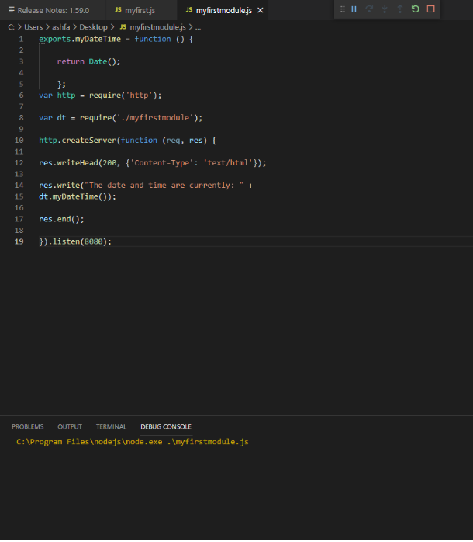

3.query string

var http = require(&#39;http&#39;);

http.createServer(function (req, res) {

res.writeHead(200, {&#39;Content-Type&#39;: &#39;text/html&#39;});

res.write(req.url);

res.end();

}).listen(8080);

4.month and yr

var http = require(&#39;http&#39;);

var url = require(&#39;url&#39;);

http.createServer(function (req, res) {

res.writeHead(200, {&#39;Content-Type&#39;: &#39;text/html&#39;});

var q = url.parse(req.url, true).query;

var txt = q.year + &quot; &quot; + q.month;

res.end(txt);

}).listen(8080);

5.NPM

var http = require(&#39;http&#39;);

var uc = require(&#39;uppercase&#39;);

http.createServer(function (req, res) {

res.writeHead(200, {&#39;Content-Type&#39;:

&#39;text/html&#39;});

res.write(uc(&quot;Hello World!&quot;));

res.end();

}).listen(8080);

6.File system

CODE:

readHTML.js

var http = require(&#39;http&#39;);

var fs = require(&#39;fs&#39;);

http.createServer(function (req, res) {

fs.readFile(&#39;demo.html&#39;, function(err, data) {

res.writeHead(200, {&#39;Content-Type&#39;: &#39;text/html&#39;});

res.write(data);

res.end();

});

}).listen(8080);

demo.html

&lt;html&gt;

&lt;body&gt;

&lt;h1&gt;Welcome to Node js&lt;/h1&gt;

&lt;p&gt;Node.js is an open-source, cross-platform, back-end JavaScript runtime

environment that runs on the V8 engine and executes JavaScript code outside a

web browser.

&lt;/p&gt;

&lt;/body&gt;

&lt;/html&gt;

APPEND FILE

CODE:

var fs = require(&#39;fs&#39;);

fs.appendFile(&#39;mynewfile1.txt&#39;, &#39;Hello content!&#39;, function

(err) {

if (err) throw err;

console.log(&#39;Saved!&#39;);

});

OPEN FILE

CODE:

var fs = require(&#39;fs&#39;);

fs.open(&#39;mynewfile2.txt&#39;, &#39;w&#39;, function (err, file) {

if (err) throw err;

console.log(&#39;Saved!&#39;);

});

WRITE FILE

CODE:

var fs = require(&#39;fs&#39;);

fs.writeFile(&#39;mynewfile3.txt&#39;, &#39;Hello content!&#39;,

function (err) {

if (err) throw err;

console.log(&#39;Saved!&#39;);

});

DELETE FILE

CODE:

var fs = require(&#39;fs&#39;);

fs.unlink(&#39;mynewfile2.txt&#39;, function (err) {

if (err) throw err;

console.log(&#39;File deleted!&#39;);

});

RENAME FILE

CODE:

fs.rename(&#39;mynewfile1.txt&#39;, &#39;myrenamedfile.txt&#39;, function (err) {

if (err) throw err;

console.log(&#39;File Renamed!&#39;);

});

10.call back function in node js.

a.

var fs = require(&quot;fs&quot;);

var data = fs.readFileSync(&#39;input.txt&#39;);

console.log(data.toString());

console.log(&quot;Program Ended&quot;);

b.

var callback = function () {

console.log(&quot;10 seconds later...&quot;);

}; setTimeout(callback, 10000);